Service postgresql start
It is used in the msf as a database for storing the data.
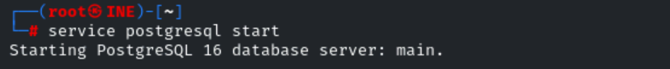
Metasploit uses PostgreSQL as its backend database to:
- Store hosts, services, vulnerabilities, and loot from scans
- Keep track of sessions and exploits used
- Enable efficient search using search, hosts, services commands
- Work with modules like db_nmap, db_import, and workspace

Msfconsole
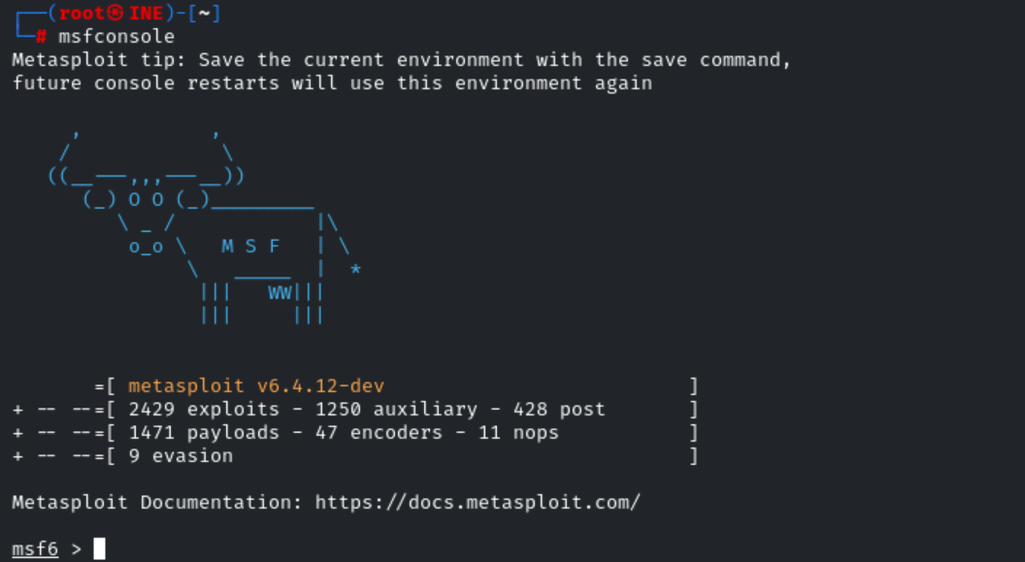
To check the status of the database we use the :
db_status
is it connected to to postgresql or not.
We need to create the workspace and use it.
Workspace
to check the workspaces.
Workspace -h
For checking the help menu.
Workspace -a umar
To create the workspace of umar name.
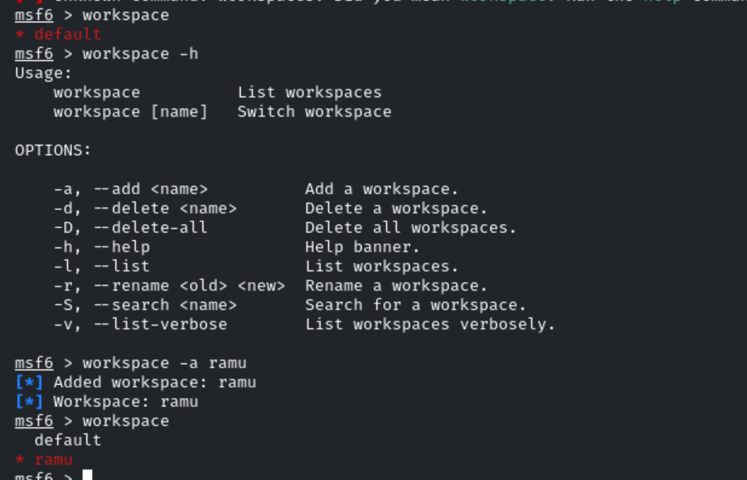

To import the file in msf :
db_import /root/umar
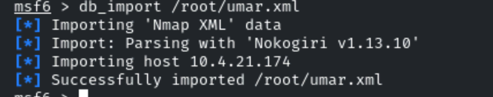
to confirm the data has been imported write:
hosts
it show all the host ip which are added.
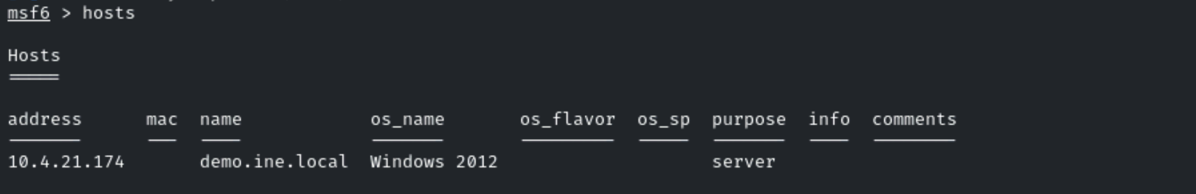
Services
To check the services of the host of which we have imported the data.
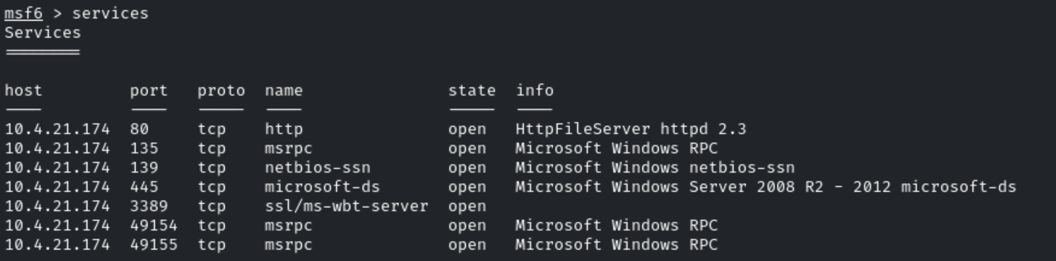
Vulns
To check the vulnerability that we discovered.
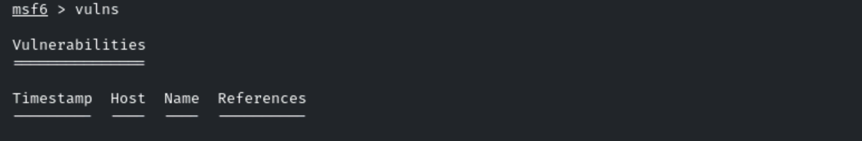
As the data that is stored doesn’t contain any vulnerabilities so it doesn't show any thing.

We can also run the nmap in the msf with the same functionality:
Db_nmap -Pn -s V 10..4.21.174
Points:
- db_status → Checks if the database is connected to PostgreSQL.
- workspace → Lists available workspaces.
- workspace -h → Displays help menu for workspace commands.
- workspace -a umar → Creates a new workspace named "umar".
- db_import /root/umar → Imports a scan result file into Metasploit.
- hosts → Shows all hosts from the imported data.
- services → Lists detected services on imported hosts.
- vulns → Displays discovered vulnerabilities.

